**GOVERNMENT COLLEGE OF ENGINEERING AND LEATHER TECHNOLOGY**

**CA2 ASSIGNMENT**

**NAME- ARIJIT GHOSAL**

**ROLL NUMBER- 11200221003**

**STREAM- INFORMATION TECHNOLOGY**

**SUBJECT- BIOLOGY**

**PAPER CODE- BSC 401**

**SEMESTER- FOURTH**

**YEAR- SECOND**

**TOPIC- Role of Information Technology for better understanding of cellular function**

**FACULTY CONCERN-** Mr. Biswajit Mondal

**DATE OF SUBMISSION- 10.03.2023**

**Role of Information Technology for better understanding of cellular function**

**Introduction to Cellular Biology**

The branch of [biology](https://en.wikipedia.org/wiki/Biology) that studies the [structure](https://en.wikipedia.org/wiki/Anatomy), [function](https://en.wikipedia.org/wiki/Physiology), and behaviour of [cells](https://en.wikipedia.org/wiki/Cell_(biology)) is called Cellular Biology. All living organisms are made of cells. A cell is the basic unit of life that is responsible for the living and functioning of organisms. Cell biology is the study of structural and functional units of cells.

There are two fundamental classifications of cells: [Prokaryotic](https://en.wikipedia.org/wiki/Prokaryote) and [Eukaryotic](https://en.wikipedia.org/wiki/Eukaryote). Prokaryotic cells do not have a true nucleus that contains their genetic material as eukaryotic cells do. Instead, prokaryotic cells have a nucleoid region, which is an irregularly-shaped region that contains the cell’s DNA and is not surrounded by a nuclear envelope. Eukaryotic cells have a nucleus enclosed within the nuclear membrane and form large and complex organisms. The cell has mitochondria. The flagella and cilia are the locomotory organs in a eukaryotic cell. Their genetic material is organized in chromosomes. The components of Eukaryotic cells are: Golgi apparatus, Mitochondria, Ribosomes, Nucleus.

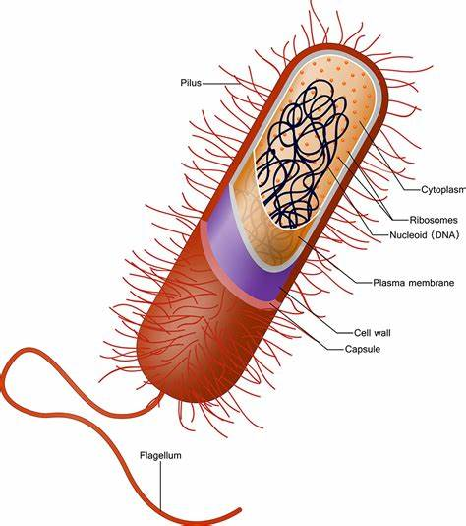 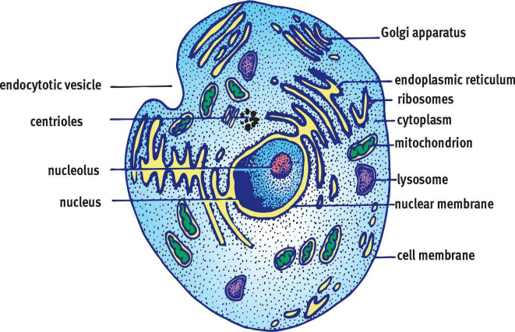

Figure 1. Prokaryotic Cell Figure 2. Eukaryotic Cell

The components of the cell are called the cell organelles. The table given below briefly states the cell organelles present and their function in Eukaryotic cells.

**Functions of the cell**

The cell performs a wide range of functions necessary for the survival and growth of organisms. Here are some of the primary functions of cells:

1. Energy production- The cells generate energy through cellular respiration, which involves the breakdown of glucose and other molecules to produce ATP (adenosine triphosphate), the primary energy currency of cells.
2. Protein synthesis- Proteins are essential for a wide range of cellular functions, including structural support and transport. The cells produce proteins

through ribosomes present within the cytoplasm.

1. Reproduction- Cells reproduce by dividing into two daughter cells through the processes of mitosis (for somatic cells) or meiosis (for reproductive cells).
2. Communication- Cells can communicate with each other through a variety of signalling pathways, including hormones, neurotransmitters, and cell-to-cell contact.
3. Transport- The transportation of molecules and other substances across their membranes through various mechanisms, including diffusion, facilitated diffusion, active transport, and endocytosis/exocytosis are facilitated by the cells.
4. Waste elimination- Cells eliminate waste products generated by cellular metabolism through various mechanisms, including diffusion, excretion, and lysosomal degradation.
5. Maintenance of homeostasis- They maintain a stable internal environment by regulating various physiological parameters, such as pH, ion concentrations, and temperature.

Overall, cells perform a wide range of functions that are essential for the survival and growth of organisms. Each cell type is specialized to perform specific functions, and the coordination of these functions is essential for maintaining the overall health and well-being of the organism.

Top of Form

Table 1

Types of Cell Organelles

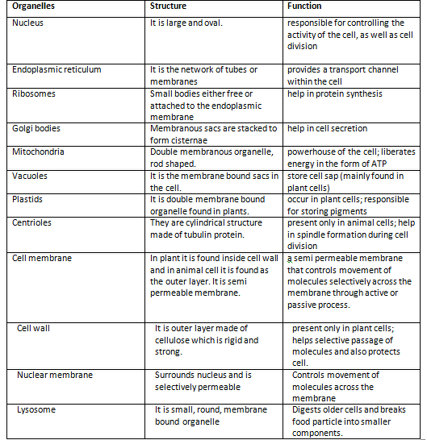

**Cell Cycle**

The cell cycle is divided into four distinct [phases](https://en.wikipedia.org/wiki/Cell_cycle#Phases)- G1, S, G2, and M. The G phase – which is the cell growth phase – makes up approximately 95% of the cycle. The proliferation of cells is instigated by progenitors. All cells start out in an identical form and can essentially become any type of cells. Cell signaling such as induction can influence nearby cells to determinate the type of cell it will become. Moreover, this allows cells of the same type to aggregate and form tissues, then organs, and ultimately systems. The G1, G2, and S phase (DNA replication, damage and repair) are considered to be the interphase portion of the cycle, while the M phase ([mitosis](https://en.wikipedia.org/wiki/Mitosis)) is the [cell division](https://en.wikipedia.org/wiki/Cell_division) portion of the cycle. Mitosis is composed of many stages which include, prophase, metaphase, anaphase, telophase, and cytokinesis, respectively. The ultimate result of mitosis is the formation of two identical daughter cells. 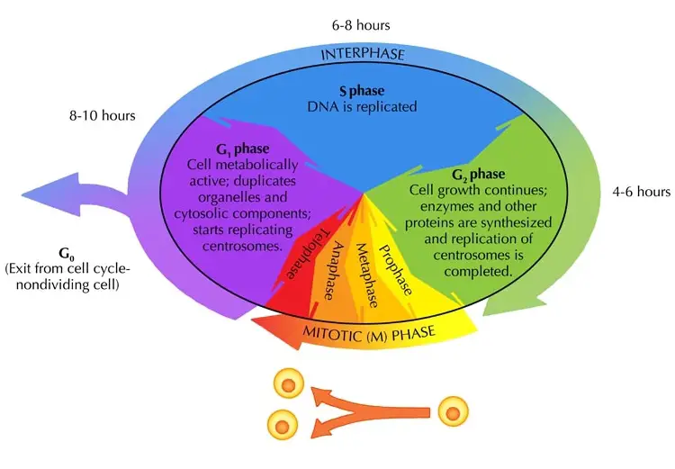tion of

Figure 3.Graphical Representation of Cell Cycle

**Importance of Cellular** Biology

The understanding of how cells work in healthy and diseased states, helps cell biologists working in animal, plant and medical science will be able to develop new vaccines, more effective medicines, plants with improved qualities and through increased knowledge a better understanding of how all living things live. Eventually it will be possible to produce a ‘health forecast’ by analysing your database of genetic and cell information. Using this you will be able to take more control over your health in a preventive way.

But cell biology is not just about disease. It has greatly assisted the human fertility programme. DNA testing has been used in archaeology to provide evidence that a living person is related to a long dead ancestor.In plant science it has been used to show that two plants that look different have the same genetic origins.

Forensic medicine uses cell biology and DNA fingerprinting to help solve murders and assaults. Neither the courts of law nor the criminals can escape the importance of cell biology.

Biotechnology uses techniques and information from cell biology to genetically modify crops to produce alternative characteristics; to clone plants and animals; to produce and ensure high quality food is available at lower costs; to produce purer medicines and in time organs for the many people who need transplants.  
Cell biology is about all this and can make an exciting career.

It is also important that everyone feels informed about how the increase in knowledge about cell biology could affect him or her and society in general. Society will have to make informed decisions about such things as growing organs for transplanting into humans and, in those areas where vitamin ‘A’ deficiency causes blindness, growing rice modified to produce the vitamin.

A basic understanding of cell biology including genetics will be as important as having some knowledge about computers and the Internet.

**Study of Cellular Biology**

As in all experimental sciences, research in cell biology depends on the laboratory methods that can be used to study cell structure and function. Many important advances in understanding cells have directly followed the development of new methods that have opened novel avenues of investigation. An appreciation of the experimental tools available to the cell biologist is thus critical to understanding both the current status and future directions of this rapidly moving area of science.

**Light microscope**

The light microscope remains a basic tool of cell biologists, with technical improvements allowing the visualization of ever-increasing details of cell structure. The contemporary light microscopes are able to magnify objects up to about a thousand times. Since most cells are between 1 and 100 μm in diameter, they can be observed by light microscopy, as can some of the larger subcellular organelles, such as nuclei, chloroplasts, and [mitochondria](https://www.ncbi.nlm.nih.gov/books/n/cooper/A2886/def-item/A3183/).

The limit of resolution of the light microscope is approximately 0.2 μm; two objects separated by less than this distance appear as a single image, rather than being distinguished from one another. This theoretical limitation of light microscopy is determined by two factors—the wavelength (λ) of visible light and the light-gathering power of the microscope lens (numerical aperture, *NA*)—according to the following equation:



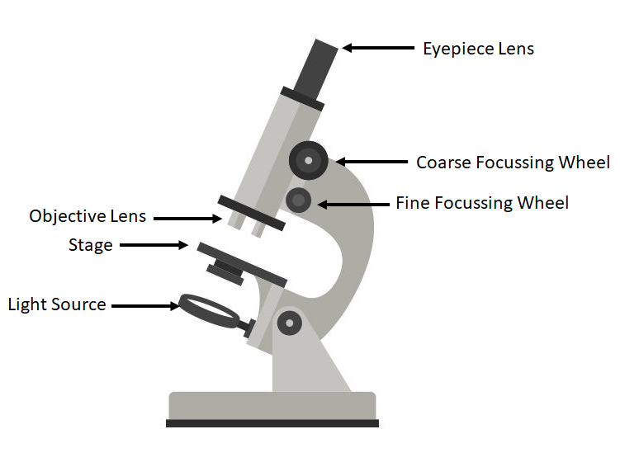

Figure 3. The Light Microscope

**Importance of Information Technology in Cellular Biology**

**Information technology has become increasingly important in cellular biology in recent years. The vast amount of data generated by modern laboratory techniques, such as high-throughput DNA sequencing and proteomics, requires sophisticated computational methods to analyse and interpret. We can now share huge amount of data through online databases among researchers and data banks. Some basic examples to emphasize the importance of software and technology in cellular biology are -**

1. **Image analysis- Software can be used to analyse digital images of cells, which is a common method for studying cellular morphology and behaviour. Image analysis software can automatically identify and measure features of interest in the images, such as cell size, shape, and movement.**
2. **Simulation- Computational models of cellular processes can be created and simulated using software. These models can help researchers understand how cells work and how they respond to different stimuli. For example, software can be used to simulate the behaviour of individual molecules in a cell or to model the spread of a virus through a population of cells.**
3. **Data analysis- High-throughput techniques such as DNA sequencing and proteomics generate vast amounts of data that can be difficult to analyse manually. Software can help researchers analyse these data quickly and accurately. For example, software can be used to identify genetic variations that are associated with disease or to detect changes in protein expression levels in response to a particular treatment.**
4. **Database management- There are many public and private databases that contain information about cellular processes, such as gene expression data, protein-protein interactions, and metabolic pathways.** Software can be used to manage and analyse these databases, making it easier for researchers to access and use this information.

Data Visualization plays a major role in understanding the various behaviour of components of the cell. The following refers to the common data visualization techniques-

1. Image processing: We need to process digital images of cells, such as those obtained through microscopy, and enhance their quality. This can include tasks such as adjusting brightness and contrast, removing noise, and sharpening the image. Once the image has been processed, software can also be used to segment the cells and extract quantitative data, such as cell size and shape.
2. Graphing and charting- The study of cell biology involves representation of data obtained through graphs and charts.This can include tasks such as plotting time-series data, generating scatterplots, and creating heatmaps. These visualizations can help researchers identify trends and patterns in the data that might not be apparent in a table or spreadsheet.
3. 3D visualization: We can create 3D models of cells and cellular structures, such as organelles and protein complexes. These models can be rotated and viewed from different angles, allowing researchers to explore the structure and function of these cellular components in greater detail.
4. Interactive visualization- Study of Information Technology provides interactive visualizations that allow researchers to explore cell data in real-time. This can include tools such as zooming, panning, and filtering, which enable researchers to focus on specific aspects of the data that are of interest.

**Evolution of Artificial Intelligence**

### Artificial intelligence (AI) allows machines to perform tasks traditionally done by humans. Machine learning (ML) is a subset of AI that enables computers to learn from data, while deep learning is a subset of ML that seeks to process information similarly to humans. In biology, AI helps to automate and simplify image analysis, predict protein structures, and aid drug discovery. Researchers are increasingly turning to artificial intelligence in biology to address complex problems. However, as an emerging concept and tool, the application of artificial intelligence (AI) in your biology research can be challenging to grasp. With Evolving technology, researchers began Caring About Artificial Intelligence. In big data, problems are getting harder to solve due to the enormity of the data that needs processing—AI helps with this! Also, researchers can focus on the bigger picture rather than analyzing hundreds or thousands of individual images or data.

### Artificial Intelligence in Image Analysis

Biology can be complicated and messy. When it comes to image analysis, researchers face many issues, including:

* The heterogeneity of the samples
* Achieving consistency in analysis, which is challenging due to human error
* Requiring complex tasks to be performed, and
* Large amounts of data making analysis time consuming

However, AI is helping to make handling these issues easier and quicker. One example of this is Aivia from Leica Microsystems.

1. Aivia uses machine learning to classify objects and pixels in an image, and deep learning to restore and increase image resolution. Here, AI enables you to easily extract essential insights from large and complex images.

Aivia 's powerful and fast 2-5D visualization and analysis unlocks all the value of your data - within a single platform.

The researchers now no longer need to learn to operate and adopt multiple imaging and analyses systems into their workflow - the Aivia platform all state-of-the-art applications provides an unified user experience. Aivia can leverage both local and cloud computing resources. We can install and use Aivia both on your local computer as well as via a web browser called the AiviaWeb. Aivia works seamlessly with all microscopy imaging systems.

It is a Powerful and fast 2-5D visualizer and analyses data which can be accessible anywhere. It also includes 22 applications and 20 pre-trained deep learning models (image segmentation, restoration and virtual staining). Aivia is reliable and easy to use cloud access with flexible IT architectures supported and supports 45 microscopy file formats

Another example of where AI is successfully applied is in analysing images in infectious disease diagnosis. While skilled microbiologists or pathologists have typically performed this kind of work, they are not immune to human error.

CRISPR-Cas9 gene editing: This technology allows researchers to edit specific genes within cells with unprecedented precision. This has led to many new insights into the function of genes and the development of new treatments for genetic diseases. CRISPR-Cas9 is a unique technology that enables geneticists and medical researchers to edit parts of the genome by removing, adding or altering sections of the DNA sequence.

It is currently the simplest, most versatile and precise method of genetic manipulation and is therefore causing a buzz in the science world.

1. The CRISPR-Cas9 system consists of two key molecules that introduce a change (mutation) into the DNA. These are:

an enzyme called Cas9. This acts as a pair of ‘molecular scissors’ that can cut the two strands of DNA at a specific location in the genome so that bits of DNA can then be added or removed.

a piece of RNA called guide RNA (gRNA). This consists of a small piece of pre-designed RNA sequence (about 20 bases long) located within a longer both strands of the DNA.

At this stage the cell recognises that the DNA is damaged and tries to repair it.

Scientists can use the DNA repair machinery to introduce changes to one or more genes in the genome of a cell of interest.

RNA scaffold. The scaffold part binds to DNA and the pre-designed sequence ‘guides’ Cas9 to the right part of the genome. This makes sure that the Cas9 enzyme cuts at the right point in the genome.

The guide RNA is designed to find and bind to a specific sequence in the DNA. The guide RNA has RNA bases that are complementary to those of the target DNA sequence in the genome. This means that, at least in theory, the guide RNA will only bind to the target sequence and no other regions of the genome.

The Cas9 follows the guide RNA to the same location in the DNA sequence and makes a cut across

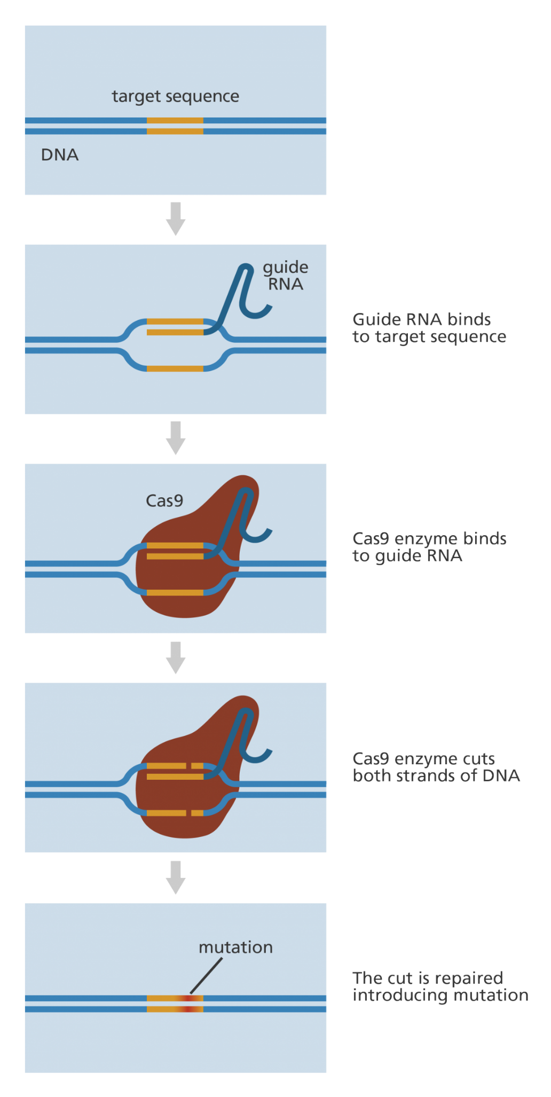

Figure 6. CSIPR genome editing technique

**Data Preparation based on Cell Function**

1. Genomics- It is the study of all of a person's genes (the genome), including interactions of those genes with each other and with the person's environment.

The study of genomics involves the process of DNA sequencing. In the most common type of sequencing used today, called sequencing by synthesis, DNA polymerase (the enzyme in cells that synthesizes DNA) is used to generate a new strand of DNA from a strand of interest. In the sequencing reaction, the enzyme incorporates into the new DNA strand individual nucleotides that have been chemically tagged with a fluorescent label. As this happens, the nucleotide is excited by a light source, and a fluorescent signal is emitted and detected. The signal is different depending on which of the four nucleotides was incorporated. This method can generate 'reads' of 125 nucleotides in a row and billions of reads at a time.

To assemble the sequence of all the bases in a large piece of DNA such as a gene, researchers need to read the sequence of overlapping segments. This allows the longer sequence to be assembled from shorter pieces, somewhat like putting together a linear jigsaw puzzle. In this process, each base has to be read not just once, but at least several times in the overlapping segments to ensure accuracy.

## Researchers can use DNA sequencing to search for genetic variations and/or mutations that may play a role in the development or progression of a disease. The disease-causing change may be as small as the substitution, deletion, or addition of a single base pair or as large as a deletion of thousands of bases.

It has been found that virtually every human ailment has some basis in our genes. Until recently, doctors were able to take the study of genes, or genetics, into consideration only in cases of birth defects and a limited set of other diseases. These were conditions, such as sickle cell anemia, which have very simple, predictable inheritance patterns because each is caused by a change in a single gene.

With the vast trove of data about human DNA generated by the Human Genome Project and other genomic research, scientists and clinicians have more powerful tools to study the role that multiple genetic factors acting together and with the environment play in much more complex diseases. These diseases, such as cancer, diabetes, and cardiovascular disease constitute the majority of health problems in the United States. Genome-based research is already enabling medical researchers to develop improved diagnostics, more effective therapeutic strategies, evidence-based approaches for demonstrating clinical efficacy, and better decision-making tools for patients and providers. Ultimately, it appears inevitable that treatments will be tailored to a patient's particular genomic makeup. Thus, the role of genetics in health care is starting to change profoundly and the first examples of the era of genomic medicine are upon us.

It is important to realize, however, that it often takes considerable time, effort, and funding to move discoveries from the scientific laboratory into the medical clinic. Most new drugs based on genome-based research are estimated to be at least 10 to 15 years away, though recent genome-driven efforts in lipid-lowering therapy have considerably shortened that interval. According to biotechnology experts, it usually takes more than a decade for a company to conduct the kinds of clinical studies needed to receive approval from the Food and Drug Administration.

Proteomics- Proteomics is the study of the proteome(proteins) and investigating how different proteins interact with each other and the roles they play within the organism.

## Techniques of proteomics-

## Low-throughput methods

### 1. Antibody-based methods

Techniques such as ELISA (enzyme-linked immunosorbent assay) and western blotting rely on the availability of antibodies targeted toward specific proteins or epitopes to identify proteins and quantify their expression levels.

### 2. Gel-based methods

Two-dimensional gel electrophoresis (2DE or 2D-PAGE), the first proteomic technique developed, uses an electric current to separate proteins in a gel based on their charge (1st dimension) and mass (2nd dimension). Differential gel electrophoresis (DIGE) is a modified form of 2DE that uses different fluorescent dyes to allow the simultaneous comparison of two to three protein samples on the same gel. These gel-based methods are used to separate proteins before further analysis by e.g., mass spectrometry (MS), as well as for relative expression profiling.

### 3. Chromatography-based methods

[Chromatography-based methods](https://www.technologynetworks.com/analysis/infographics/comparing-chromatography-techniques-321785) can be used to separate and purify proteins from complex biological mixtures such as cell lysates. For example, ion-exchange chromatography separates proteins based on charge, size exclusion chromatography separates proteins based on their molecular size, and affinity chromatography employs reversible interactions between specific affinity ligands and their target proteins (e.g., the use of lectins for purifying IgM and IgA molecules). These methods can be used to purify and identify proteins of interest, as well as to prepare proteins for further analysis by e.g., downstream MS.[8](https://doi.org/10.1093/chromsci/bmw167)

High-throughput methods:

### 1. Analytical, functional and reverse-phase microarrays

Protein microarrays apply small amounts of sample to a “chip” for analysis (this is sometimes in the form of a glass slide with a chemically modified surface). Specific antibodies can be immobilized to the chip surface and used to capture target proteins in a complex sample. This is termed an analytical protein microarray, and these types of microarray are used to measure the expression levels and binding affinities of proteins in a sample. Functional protein microarrays are used to characterize protein functions such as protein–RNA interactions and enzyme-substrate turnover. In a reverse-phase protein microarray, proteins from e.g., healthy vs. diseased tissues or untreated vs. treated cells are bound to the chip, and the chip is then probed with antibodies against the target proteins.

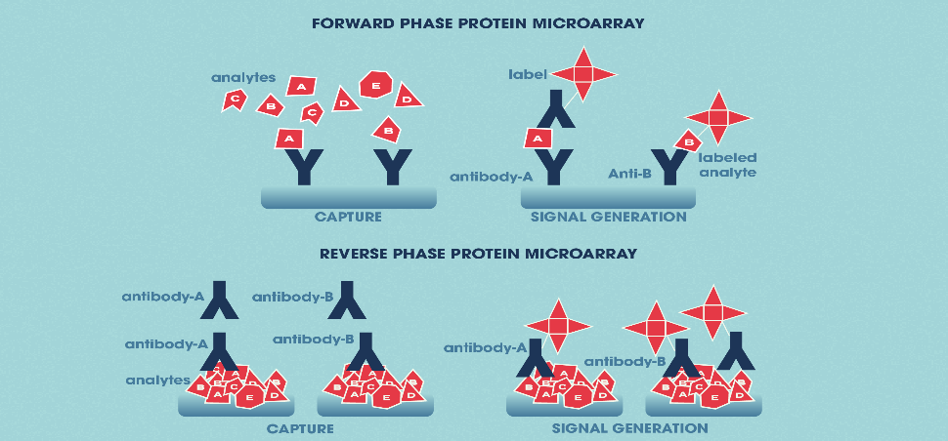

Figure 7. Forward and Reverse Phase protein microarray

### 2. Mass spectrometry-based proteomics

There are several “gel-free” methods for separating proteins, including isotope-coded affinity tag (ICAT), stable isotope labelling with amino acids in cell culture (SILAC) and isobaric tags for relative and absolute quantitation (iTRAQ). These approaches allow for both quantitation and comparative/differential proteomics. There are also other, less quantitative techniques such as multidimensional protein identification technology (MudPIT), which offer the advantages of being faster and simpler and other gel-free, chromatographic techniques for protein separation include [gas chromatography](https://www.technologynetworks.com/analysis/articles/gas-chromatography-339363) (GC) and liquid chromatography (LC).

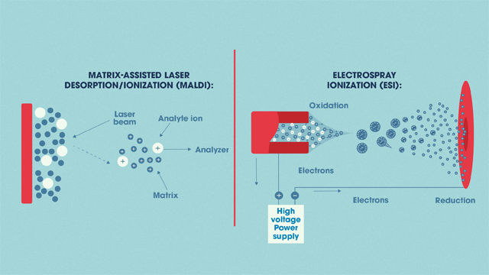

Figure 7. The two main ionization sources in MS-based proteomics*.*

**Conclusion**

The field of cell biology has made significant advancements over the years. Some of the key advancements include the discovery of cells, the development of cell theory, and the identification of cell organelles such as the nucleus, mitochondria, and ribosomes.

With the advent of new technologies, researchers have been able to gain a deeper understanding of cellular processes. For example, the development of electron microscopy has allowed for the visualization of subcellular structures, while advances in molecular biology have enabled the study of cellular processes at the molecular level.

Recent advancements in the field of cell biology include the use of single-cell analysis to identify cellular heterogeneity, the development of 3D printing technology for tissues and organs, the use of CRISPR gene editing to manipulate genes in cells, the study of systems biology to understand complex cellular interactions, and the use of synthetic biology to build artificial biological systems. Overall, the study of cell biology continues to evolve and expand with new discoveries and technological advancements, offering promising opportunities for disease diagnosis and treatment.

Thus, the demand of Information technology and applications of various softwares has an huge impact on modern day study of cellular functions and can be useful in exploring more in this field.

**References**

# 1. [Brian Stucky](https://pubmed.ncbi.nlm.nih.gov/?term=Stucky+B&cauthor_id=34448841) [4](https://pubmed.ncbi.nlm.nih.gov/34448841/#affiliation-4), [Jin Wang](https://pubmed.ncbi.nlm.nih.gov/?term=Wang+J&cauthor_id=34448841) . Artificial Intelligence for Biology

National library of Medicine website: <https://pubmed.ncbi.nlm.nih.gov/>

# 2. Natasha Beeton-Kempen (2020) .Proteomics: Principles, Techniques and Applications

https://www.technologynetworks.com/

3. A brief guide to Genomics

National Human Genome Research Institute website: <https://www.genome.gov/>

4.Cornelia Kasper. Cell Culture Technologies